[1]

TCP/ IP PROTOCOLS

First A. Author, *Fellow, IEEE*, Second B. Author, and Third C. Author, Jr., *Member, IEEE*

***Abstract*—** **Through protocol suites, computers connected to a network may communicate. The most popular and easily available set of protocols is TCP/IP. A communications protocol suite is assembled up of layers, all of them symbolises a distinct function that a protocol may accomplish. In order to carry out its assigned duties, each layer often provides a variety of protocol alternatives. The four levels that make up TCP/four-layer IP's structure are as follows: 1. The application layer; 2. The transport layer; 3. The network layer; and 4. The data link layer.**

***Index Terms*—Application, Addressing, Routing, Fragmentation, Packet, Datagram, Protocol suite**

# I. INTRODUCTION

T

he number of Internet users utilizing it has significantly increased, and loads of them are employing tools and services which were previously accessible only on a small amount of computers and only to highly skilled operators. The explosion of books, articles, seminars, and even TV programmes devoted to the Internet and Transmission Control Protocol/ Internet Protocol (TCP/IP) is evidence of this increase in usage. In fact, because there are several of these books that majority of publishers are unwilling to approve more since booksellers are at their maximum capacity for shelf space. This article's goal is to give a general introduction of the Internet and TCP/IP with an emphasis on its background, vocabulary, and core ideas. It offers suggestions for other sources for more in-depth knowledge while acting as a clear beginning point and guide.

**Fig 1:** TCP/IP protocol stack.

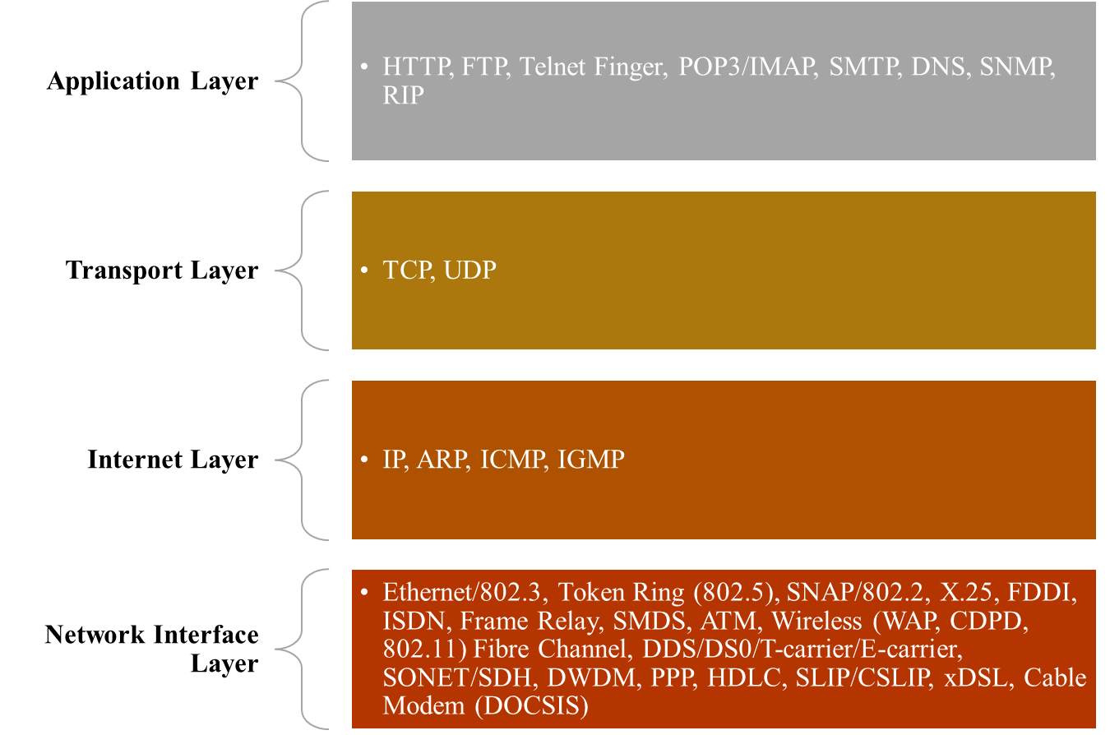

Even while it is now widely understood that the Internet is a network that is profoundly altering social, political, and economic structures as well as transcending geographical boundaries, this capacity is the result of predictions made about 60 years ago. In a series of memoranda dating back to August 1962, J.C.R. Licklider from MIT described his idea of a "Galactic Network" and the potential for networking to promote social connections.[1] The Internet undeniably offers a national and global infrastructure, and there have even been substantial discussions regarding interplanetary Internet communication.

The U.S. Department of Defense (DoD) initially supported an effort to connect American research facilities as the forerunner of the contemporary Internet. In 1967, Larry Roberts presented the initial design for ARPANET at an ACM meeting. ARPANET was named after ARPA, which stands for DoD’s Advanced Research Projects Agency.[2] In December 1968, BBN received a deal from ARPA to create and deploy a packet switching network with a targeted line speed of 50 kbps.[3] In September 1969, UCLA became the first ARPANET node. Nodes were thereafter added each month at SRI, UCSB, and Utah.[4] By the end of 1969, there were four nodes on ARPANET. It covered the whole continental United States by 1971, and by 1973 it had links to Europe.

The first communications protocol introduced in ARPANET was NCP.[5] NCP, however, was unable to manage the increasing volume of network traffic. The ARPANET was upgraded in 1974 to use a new set of more reliable communications protocols built on TCP for end-to-end network communication. However, it was decided that handling an end-to-end protocol through intermediary gateways was unnecessary. This led to a new architecture in 1978 that divided tasks between TCP for dependable host connection and IP for packet routing and device-to-device communication.[6] The protocol set is typically referred to as just TCP/IP because TCP and IP were first conceptualised as a single protocol.

# II. TCP/ IP Protocols Architecture

## The TCP/IP protocols architecture is a layered structure that forms the foundation of communication within the TCP/IP network. It consists of multiple layers, each with specific functions and responsibilities.[7] The four components that constitute the structure are the application layer, transport layer, network layer, and data link layer. Each layer carries out certain activities and makes use of different protocols to do so.[8] The Application layer encompasses protocols that facilitate communication between network applications. The Transport layer ensures reliable data transfer, employing protocols like TCP and UDP. The Network layer handles addressing, routing, and packet delivery, while the Data Link layer manages physical network connections. This layered architecture enables efficient and scalable communication within the TCP/IP network.

## The Unix OS is predominantly linked with TCP/IP. Although they were initially developed independently, as mentioned earlier, their histories have been intertwined since the inclusion of TCP/IP protocols with the 4.2BSD Unix operating system.[9] However, it's important to remember that all of the popular operating systems in use today can access TCP/IP protocols.

The TCP/IP protocol architecture is depicted in figure 1. While it is not a complete picture, it does emphasise the essential protocol and application elements included in the bulk of commercial TCP/IP software packages. It demonstrates how they are connected.

## The network Interface Layer

The TCP/ IP protocols are made to work with different wide- or local-area network technologies. IP messages may be transmitted across the technologies shown in the image as well as many others, however some modifications could be required. The majority of these underlying protocols and technologies are complex and outside the purview of this text.

TCP/IP, however, is relevant to two distinct network interface protocols. The Serial Line Internet Protocol (SLIP, RFC 1055) [10] and Point-to-Point Protocol (PPP, RFC 1661) [11] are used when there is no other underlying data connection protocol available, such as in leased line or dial-up scenarios to offer data link layer protocol services.[12] These two protocols are found in the majority of PC-class TCP/IP software packages.

By using SLIP or PPP, a remote computer may establish a direct connection to a host server and utilise IP to access the Internet as opposed to being limited to an asynchronous connection.

## The Internet Layer

Services offered by the OSI Network Layer are broadly equivalent to those provided by the Internet Protocol (RFC 791) [13]. Datagram service, a connectionless transport service offered by IP, is available throughout the network. Since the network does neither guarantee delivery or alert the end host system about lost packets caused by mistakes or network congestion, this service is frequently referred to as being unreliable. IP datagrams are made up of messages or single message fragments that can be up to 65,535 bytes in length (octets). Additionally, IP does not provide a flow control system.

1. As a routable protocol, the Internet Protocol is in charge of IP addressing, routing, packet fragmentation, and reassembly.
2. The job of translating Internet layer addresses to Network layer addresses is handled by the Address Resolution Protocol.
3. When IP packets are unable to be delivered, the Internet Control Message Protocol is in charge of providing diagnostic tools and reporting faults.
4. IP multicast groups are managed using the Internet Group Management Protocol.
5. *The Transport Layer*

The OSI Transport and Session Layers are represented by two protocols in the TCP/IP protocol family. These protocols go by the names Transmission Control Protocol (TCP) and User Datagram Protocol (UDP). Since the bulk of these apps use either TCP or UDP, it might be argued that calling them "TCP/IP applications" is a little misleading.

1. **TCP**

TCP delivers a connection-oriented communication service and serves as a virtual circuit over the network, according to RFC 793 [14]. It includes formatting rules for messages, rules for creating and closing virtual circuits, rules for sequencing, rules for flow management, and rules for error correction. The bulk of programmes in the TCP/IP suite make use of TCP's reliable transport service.

Data segments are what TCP refers to as a unit of data. Because TCP does not distinguish between different messages, this phrase is used. Instead, it sends a block of bytes between the sender and recipient from the byte stream.

1. **UDP**

UDP, as outlined in RFC 768[15], offers a connectionless datagram service, providing end-to-end communication. Certain applications, particularly those involving simple query and response scenarios, are more suitable for UDP's datagram service. This is because there is no time wasted on establishing and terminating virtual circuits. In order to create a socket for the programme, UDP basically works by attaching a port number to the IP address.

1. *The Application Layer*

The communication between network applications and the underlying network infrastructure takes place at the Application layer of the TCP/IP protocol stack. It offers a framework for network data sharing between apps. Different protocols and services are included at this layer to facilitate communication between end systems. Common protocols present at the application layer include DNS for domain name resolution, SMTP for email transmission, FTP for file transfer, and HTTP for web surfing. At this layer, there are also utilities and protocols that are specialised to certain applications. The Application layer plays a vital role in facilitating seamless communication and enabling a wide range of functionalities within the TCP/IP network architecture.

The protocols used by applications to communicate data are included in the Application layer, which is located on top of the protocol stack.

This layer's protocols include

* + HTTP, which is used for sharing the files that make up web pages on the Internet.
  + File transmission that is interactive is done via FTP.
  + SMTP is used to send and receive messages and attachments.
  + Telnet enables remote network host login.

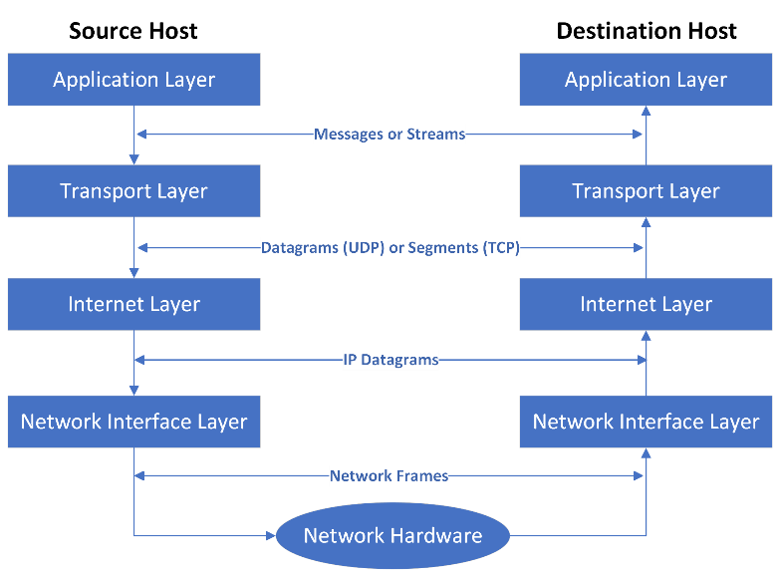

**Fig 2:** Example for communication between two hosts

# III. Conclusion

TCP/IP is an extensive suite of protocols, applications, and utilities, as this essay has shown, rather than just a collection of communication methods. The older term is still frequently used and is anticipated to continue for the foreseeable future, regardless of the reality that the Internet Protocol Suite is a more common name for these protocols.

The interconnections between the various protocol levels inside TCP/IP are shown in Figure 2. Host systems have applications and tools that enable communication between them. Among the two hosts, TCP establishes a trustworthy virtual circuit link. UDP (not illustrated) offers an end-to-end datagram connection inside this layer. With regard to both local and wide area networks, IP provides a datagram transport service via a number of subnetworks. Different widely used local or wide area network technologies may be used by the underlying subnetwork.

It's crucial to remember that the term "gateway" in this context refers to the physical component that connects two subnets. In LAN contexts, this device is usually referred to as a router, however in OSI environments, it is recognised as an intermediary system. In OSI terminology, a gateway is utilised to provide protocol translation between two networks and/or applications.

References

[1] Barry M. Leiner, Vinton G. Cerf, David D. Clark, Jon Postel, Larry G. Roberts, and Stephen Wolff, “Brief History of the Internet,” *https://www.internetsociety.org/internet/history-internet/brief-history-internet/#JCRL62*, 1997.

[2] Kevin Featherly, “ARPANET,” *https://www.britannica.com/topic/ARPANET*.

[3] Computer History Museum, “Internet History of 1960s,” *https://www.computerhistory.org/internethistory/1960s/*.

[4] Scientific american, “Early sketch of ARPANET’s first four nodes,” *https://www.scientificamerican.com/gallery/early-sketch-of-arpanets-first-four-nodes/*, 2009.

[5] R. T. Braden, “A Server Host System on the ARPANET,” in *Proceedings of the Fifth Symposium on Data Communications*, in SIGCOMM ’77. New York, NY, USA: Association for Computing Machinery, 1977, pp. 4.1–4.9. doi: 10.1145/800103.803337.

[6] E. Trouva *et al.*, “Is the Internet an unfinished demo? Meet RINA!,” in *TERENA networking conference*, 2010, pp. 1–12.

[7] Mary E. Shacklett, “TCP/IP,” *https://www.techtarget.com/searchnetworking/definition/TCP-IP*, 2021.

[8] Software Testing Help, “7 Layers of The OSI Model (A Complete Guide),” *https://www.softwaretestinghelp.com/osi-model-layers/*, 2023.

[9] M. Townes, “The Spread of TCP/IP: How the Internet Became the Internet,” *Millennium*, vol. 41, no. 1, pp. 43–64, 2012, doi: 10.1177/0305829812449195.

[10] “Nonstandard for transmission of IP datagrams over serial lines: SLIP,” no. 1055. in Request for Comments. RFC Editor, Jun. 1988. doi: 10.17487/RFC1055.

[11] W. A. Simpson, “The Point-to-Point Protocol (PPP),” no. 1661. in Request for Comments. RFC Editor, Jul. 1994. doi: 10.17487/RFC1661.

[12] C. Walls, “Chapter 8 - Networking,” in *Embedded Software (Second Edition)*, C. Walls, Ed., Second Edition.Oxford: Newnes, 2012, pp. 287–335. doi: https://doi.org/10.1016/B978-0-12-415822-1.00008-8.

[13] “Internet Protocol,” no. 791. in Request for Comments. RFC Editor, Sep. 1981. doi: 10.17487/RFC0791.

[14] Information Sciences Institute University of Southern California, “TRANSMISSION CONTROL PROTOCOL,” *https://www.rfc-editor.org/rfc/rfc793*, 1981.

[15] “User Datagram Protocol,” *https://www.ietf.org/rfc/rfc768.txt*, 1980.

1.